Mega Evolution

Mega Evolution (Japanese: メガシンカ Mega Evolution) is a transformation affecting Pokémon. Mega Evolutions are identified by having "Mega" in front of their name.
Korrina, the Gym Leader of Shalour City, is said to know secrets about Mega Evolution. The Tower of Mastery is also related to Mega Evolution. According to a Kalos legend, the first Pokémon to have been Mega Evolved was a Lucario. However, according to Zinnia's grandmother in Pokémon Omega Ruby and Alpha Sapphire, Rayquaza was the first Pokémon to Mega Evolve; Mega Evolution was first discovered by the first meeting of humanity and Rayquaza.

Mega Evolving


The Mega Evolution sigil, as seen in Pokémon Tretta
In order to Mega Evolve, the Pokémon must be holding the appropriate Mega Stone (with the exception of Rayquaza which is only required to know the move Dragon Ascent), and its Trainer must have a Key Stone. Professor Sycamore theorizes that even with the Mega Stone and the respective item to resonate with the stone, Mega Evolution cannot be achieved if there is not a strong bond between Trainer and Pokémon.
Once per battle, only a single Pokémon for each Trainer may Mega Evolve. Switching the Mega Evolved Pokémon out will not dissolve a Mega Evolution. A Mega Evolved Pokémon can only revert back to its original state upon fainting or the conclusion of the battle. If a Mega Evolved Pokémon faints, but is later revived, that Pokémon cannot obtain a Mega Evolved state again for the remaining duration of the battle. Trainers on the same team during a Multi Battle will each be able to Mega Evolve once during the battle.
Mega Stones cannot be taken via Thief, Covet, Trick, or Switcheroo. Abilities such as Magician and Pickpocket will fail to snatch the Mega Stone from its holder and Pokémon with Klutz are able to use their respective Mega Stone. If used by the holder, moves such as Bestow, Fling, Trick and Switcheroo will always fail. Embargo and Magic Room also have no effect, and will not prevent a Pokémon from using its Mega Stone to Mega Evolve. Using Knock Off against a Pokémon holding its respective Mega Stone will not remove the item, nor will Knock Off's added effect of increased power on the turn it removes an item be granted. Likewise, Mega Stones also cannot be given to or taken by their respective species using any of the aforementioned moves or Abilities.
A Pokémon cannot Mega Evolve while shifting position in a Triple Battle, nor during the airborne phase of Sky Drop. Neither volatile nor non-volatile status conditions such as paralysis, sleep, and infatuation will have any effect over a Pokémon's ability to Mega Evolve; even if they result in the Pokémon not being able to move that turn, the Mega Evolution will occur regardless.
Performing Mega Evolution will not alter the turn order, so a Pokémon with a lower Speed than their opponent will still go after them on the one turn the Mega Evolution occurs, even if their Mega Evolution increases Speed and would otherwise cause them to go first. The opposite is also true for Pokémon who lose Speed from Mega Evolution, such as Garchomp. However, turn order will be determined normally on every turn afterwards. All other stat changes and type changes of a Mega Evolution will take effect immediately and damage calculation will proceed as usual. (A Pokémon whose Mega Evolution possesses a lower Defense stat, for example, will take greater damage from Physical attacks on the turn of Mega Evolving.)
Changes in a Pokémon's Ability will also take place immediately. A Sharpedo with Speed Boost will not gain a boost in speed at the end of the turn it Mega Evolves, but if it uses a biting move such as Crunch that turn, it will be boosted by Strong Jaw, Mega Sharpedo's Ability.
Since movement order is determined before any moves are used (except changes due to Quash and After You), the Pokémon's new Speed or Ability will not affect movement order during the turn which it Mega Evolves.
In Pokémon Omega Ruby and Alpha Sapphire, Mega Evolution can also occur during the Talent round of Pokémon Contest Spectaculars. If the participating Pokémon is holding its corresponding Mega Stone when its appeal causes the audience's excitement to reach its peak, it will Mega Evolve and perform a Spectacular Talent. The Pokémon will remain in its Mega Evolved state for the remainder of the Talent round.

Effects
A Mega-Evolved Pokémon has different base stats, with the exception of HP, and can have a different Ability and type from its non-Mega-Evolved form. Every Mega-Evolved Pokémon except for Mega Alakazam has a base stat total 100 points higher than that of its base form.

Pokémon capable of Mega Evolution

Introduced in X and Y
Pokémon | Before Mega Evolution |  |  | After Mega Evolution |  |  | Mega Stone
Pokémon | Image | Type | Ability | Image | Type | Ability | Mega Stone
Venusaur | 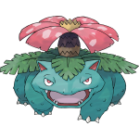 | Grass Poison | Overgrow  Chlorophyll (Hidden) | 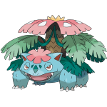 | Grass Poison | Thick Fat |   Venusaurite
Charizard | 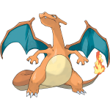 | Fire Flying | Blaze  Solar Power (Hidden) | 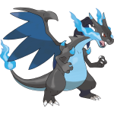 | Fire Dragon | Tough Claws |   Charizardite X
 |  |  |  | 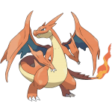 | Fire Flying | Drought |   Charizardite Y
Blastoise | 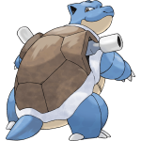 | Water | Torrent  Rain Dish (Hidden) | 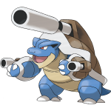 | Water | Mega Launcher |   Blastoisinite
Alakazam | 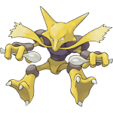 | Psychic | Synchronize or  Inner Focus  Magic Guard (Hidden) | 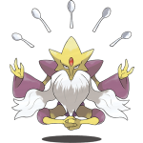 | Psychic | Trace |   Alakazite
Gengar | 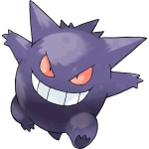 | Ghost Poison | Levitate | 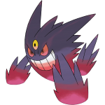 | Ghost Poison | Shadow Tag |   Gengarite
Kangaskhan | 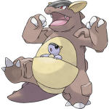 | Normal | Early Bird or  Scrappy  Inner Focus (Hidden) | 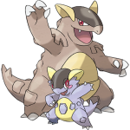 | Normal | Parental Bond |   Kangaskhanite
Pinsir | 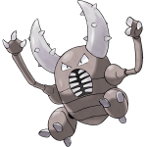 | Bug | Hyper Cutter or  Mold Breaker  Moxie (Hidden) | 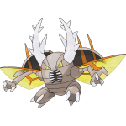 | Bug Flying | Aerilate |   Pinsirite
Gyarados | 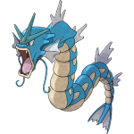 | Water Flying | Intimidate  Moxie (Hidden) | 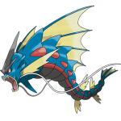 | Water Dark | Mold Breaker |   Gyaradosite
Aerodactyl | 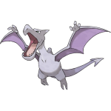 | Rock Flying | Rock Head or  Pressure  Unnerve (Hidden) | 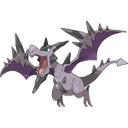 | Rock Flying | Tough Claws |   Aerodactylite
Mewtwo | 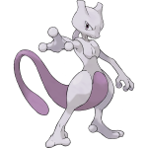 | Psychic | Pressure  Unnerve (Hidden) | 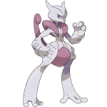 | Psychic Fighting | Steadfast |   Mewtwonite X
 |  |  |  | 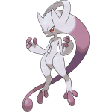 | Psychic | Insomnia |   Mewtwonite Y
Ampharos | 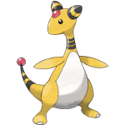 | Electric | Static  Plus (Hidden) | 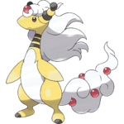 | Electric Dragon | Mold Breaker |   Ampharosite
Scizor | 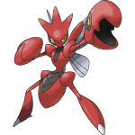 | Bug Steel | Swarm or  Technician  Light Metal (Hidden) | 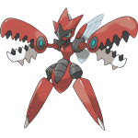 | Bug Steel | Technician |   Scizorite
Heracross | 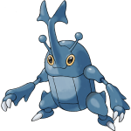 | Bug Fighting | Swarm or  Guts  Moxie (Hidden) | 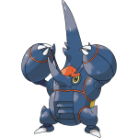 | Bug Fighting | Skill Link |   Heracronite
Houndoom | 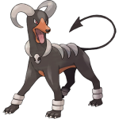 | Dark Fire | Early Bird or  Flash Fire  Unnerve (Hidden) | 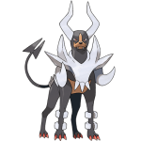 | Dark Fire | Solar Power |   Houndoominite
Tyranitar | 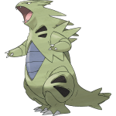 | Rock Dark | Sand Stream  Unnerve (Hidden) | 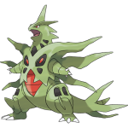 | Rock Dark | Sand Stream |   Tyranitarite
Blaziken | 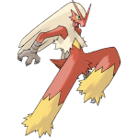 | Fire Fighting | Blaze  Speed Boost (Hidden) | 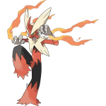 | Fire Fighting | Speed Boost |   Blazikenite
Gardevoir | 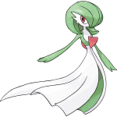 | Psychic Fairy | Synchronize or  Trace  Telepathy (Hidden) | 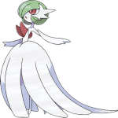 | Psychic Fairy | Pixilate |   Gardevoirite
Mawile | 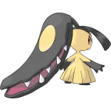 | Steel Fairy | Hyper Cutter or  Intimidate  Sheer Force (Hidden) | 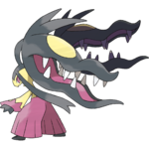 | Steel Fairy | Huge Power |   Mawilite
Aggron | 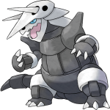 | Steel Rock | Sturdy or  Rock Head  Heavy Metal (Hidden) | 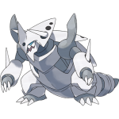 | Steel | Filter |   Aggronite
Medicham | 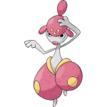 | Fighting Psychic | Pure Power  Telepathy (Hidden) | 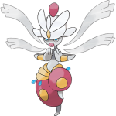 | Fighting Psychic | Pure Power |   Medichamite
Manectric | 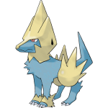 | Electric | Static or  Lightning Rod  Minus (Hidden) | 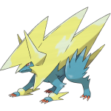 | Electric | Intimidate |   Manectite
Banette | 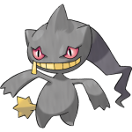 | Ghost | Insomnia or  Frisk  Cursed Body (Hidden) | 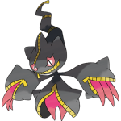 | Ghost | Prankster |   Banettite
Absol | 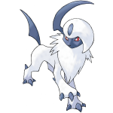 | Dark | Pressure or  Super Luck  Justified (Hidden) | 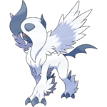 | Dark | Magic Bounce |   Absolite
Garchomp | 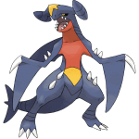 | Dragon Ground | Sand Veil  Rough Skin (Hidden) | 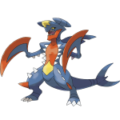 | Dragon Ground | Sand Force |   Garchompite
Lucario | 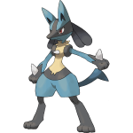 | Fighting Steel | Steadfast or  Inner Focus  Justified (Hidden) | 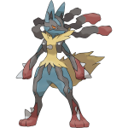 | Fighting Steel | Adaptability |   Lucarionite
Abomasnow | 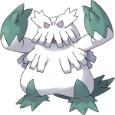 | Grass Ice | Snow Warning  Soundproof (Hidden) | 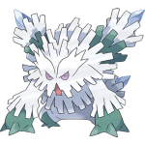 | Grass Ice | Snow Warning |   Abomasite

Introduced in Omega Ruby and Alpha Sapphire
Pokémon | Before Mega Evolution |  |  | After Mega Evolution |  |  | Mega Stone
Pokémon | Image | Type | Ability | Image | Type | Ability | Mega Stone
Beedrill | 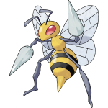 | Bug Poison | Swarm  Sniper (Hidden) | 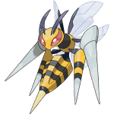 | Bug Poison | Adaptability |   Beedrillite
Pidgeot | 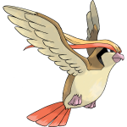 | Normal Flying | Keen Eye or  Tangled Feet  Big Pecks (Hidden) | 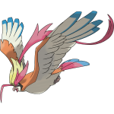 | Normal Flying | No Guard |   Pidgeotite
Slowbro | 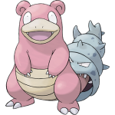 | Water Psychic | Oblivious or  Own Tempo  Regenerator (Hidden) | 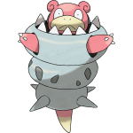 | Water Psychic | Shell Armor |   Slowbronite
Steelix | 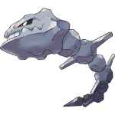 | Steel Ground | Rock Head or  Sturdy  Sheer Force (Hidden) | 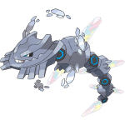 | Steel Ground | Sand Force |   Steelixite
Sceptile | 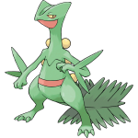 | Grass | Overgrow  Unburden (Hidden) | 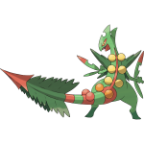 | Grass Dragon | Lightning Rod |   Sceptilite
Swampert | 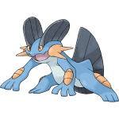 | Water Ground | Torrent  Damp (Hidden) | 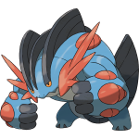 | Water Ground | Swift Swim |   Swampertite
Sableye | 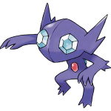 | Dark Ghost | Keen Eye or  Stall  Prankster (Hidden) | 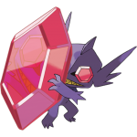 | Dark Ghost | Magic Bounce |   Sablenite
Sharpedo | 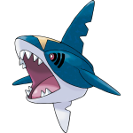 | Water Dark | Rough Skin  Speed Boost (Hidden) | 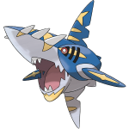 | Water Dark | Strong Jaw |   Sharpedonite
Camerupt | 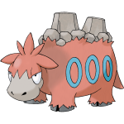 | Fire Ground | Magma Armor or  Solid Rock  Anger Point (Hidden) | 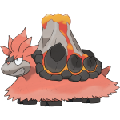 | Fire Ground | Sheer Force |   Cameruptite
Altaria |  | Dragon Flying | Natural Cure  Cloud Nine (Hidden) |  | Dragon Fairy | Pixilate |   Altarianite
Glalie |  | Ice | Inner Focus or  Ice Body  Moody (Hidden) | 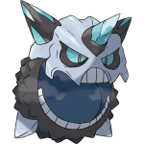 | Ice | Refrigerate |   Glalitite
Salamence | 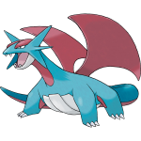 | Dragon Flying | Intimidate  Moxie (Hidden) | 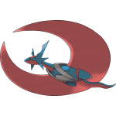 | Dragon Flying | Aerilate |   Salamencite
Metagross | 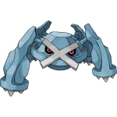 | Steel Psychic | Clear Body  Light Metal (Hidden) | 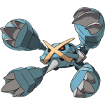 | Steel Psychic | Tough Claws |   Metagrossite
Latias | 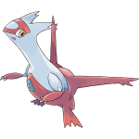 | Dragon Psychic | Levitate | 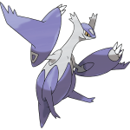 | Dragon Psychic | Levitate |   Latiasite
Latios | 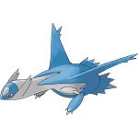 | Dragon Psychic | Levitate | 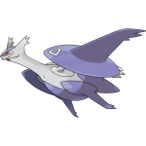 | Dragon Psychic | Levitate |   Latiosite
Rayquaza | 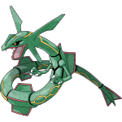 | Dragon Flying | Air Lock | 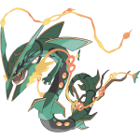 | Dragon Flying | Delta Stream | None*
Lopunny | 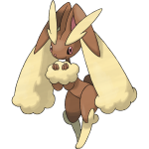 | Normal | Cute Charm or  Klutz  Limber (Hidden) | 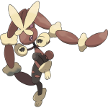 | Normal Fighting | Scrappy |   Lopunnite
Gallade | 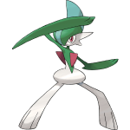 | Psychic Fighting | Steadfast  Justified (Hidden) | 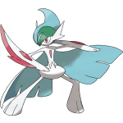 | Psychic Fighting | Inner Focus |   Galladite
Audino |  | Normal | Healer or  Regenerator  Klutz (Hidden) |  | Normal Fairy | Healer |   Audinite
Diancie | 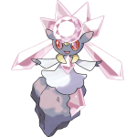 | Rock Fairy | Clear Body |  | Rock Fairy | Magic Bounce |   Diancite

In other games
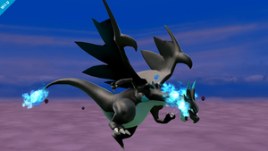

Charizard as Mega Charizard X in Super Smash Bros. for Wii U

Super Smash Bros. for Nintendo 3DS/Wii U
Charizard's, Lucario's, and Mewtwo's Final Smashes Mega Evolve them into Mega Charizard X, Mega Lucario, and Mega Mewtwo Y, respectively. While Lucario and Charizard's Mega Forms are used as a temporary power-up, Mewtwo's is used to perform Psystrike.
The Mega Evolutions of Blastoise, Blaziken, Kangaskhan, Venusaur, Lucario, Mewtwo (both forms), and Charizard (X form) appear as trophies in the Wii U version, while only Mega Venusaur and Blastoise appear in the 3DS version.

Pokkén Tournament
So far, Lucario, Gardevoir, Gengar, Charizard, and Blaziken are known to Mega Evolve through Resonance Burst mode. Little is known how it is triggered.

Pokémon Shuffle
Mega Evolutions play a role in this game. Before they can be initiated, the Mega forms must be defeated to obtain their respective Mega Stones. A gauge may be filled by matching the respective Pokémon or a Pokémon with the same type and the skill Mega Boost. After it fills, each of the indicated species' pieces will change to a special piece according to the species. Effects for each Mega form vary for each species.
The following Mega Stones are available, in the order received: Audinite, Kangaskhanite, Sablenite, Slowbronite, Lopunnite, Altarianite, Mawilite, Ampharosite, Glalitite, Gengarite, Mewtwonite Y, Aerodactylite, and Heracronite. Lucarionite, Blastoisinite, Banettite, Venusaurite, Manectite, and Blazikenite were distributed in events.

Mega Effects
Pokémon |  | Effect
Mega Audino |  | Erases all Pokémon within one space of the match.
Mega Kangaskhan |  | Erases all Pokémon in the five columns to the left and right.
Mega Sableye |  | Erases all Pokémon in an O-shaped pattern.
Mega Slowbro |  | Adds one more Mega Slowbro above the match.
Mega Lopunny |  | Erases all Pokémon five rows above and five rows below.
Mega Altaria |  | Erases all Pokémon within two spaces of the match.
Mega Mawile |  | Erases diagonal Pokémon from upper-right to lower-left corner.
Mega Ampharos |  | A random lightning strike erases a jagged line of Pokémon.
Mega Glalie |  | Erases all Pokémon in a V-shaped pattern.
Mega Gengar |  | Erases all Mega Gengar in the puzzle area.
Mega Mewtwo Y |  | Clears a Pokémon with the same type as Mega Mewtwo Y (max 10).
Mega Aerodactyl |  | Erases rocks and blocks (max 10), and also does damage to the foe.
Mega Heracross |  | Adds one more Mega Heracross to the left of the match.
Mega Lucario |  | Erases all Pokémon five rows above and five rows below.
Mega Blastoise |  | Erases all Pokémon within two spaces of the match.
Mega Banette |  | Clears one kind of Pokémon with the same type as Mega Banette (max 10).
Mega Venusaur |  | Erases all Pokémon in the five columns to the left and right.
Mega Manectric |  | A vertical lightning strike erases a jagged line of Pokémon.
Mega Blaziken |  | ?

Pokémon Rumble World
In Pokémon Rumble World, the player gains the ability to Mega Evolve their Pokémon after completing the challenge "Raid of the Mighty General", then receiving the Special Stone Shop and a Mega Key from the rewards section of the ordinary shop. Mega Stones for currently owned Pokémon can be bought and immediately attached to its corresponding Pokémon using the Special Stone Shop. The first Mega Stone of the player's choice is free (unless either the Red or Blue Orb is chosen instead) and every one after it costs 5 Poké Diamonds. During battle, Mega Evolution can performed by tapping the Mega Evolution button using a Pokémon equipped with a Mega Stone in battle. Mega Evolution can be used again on any Pokémon in the same battle, unlike in the main games.
Mega Evolved Pokémon revert after a completed trip, or when they are defeated or switched out. Mega Evolving will send out a shockwave that damages enemy Pokémon. This shockwave is capable of defeating and tipping over opposing Pokémon.

In the TCG
Mega Evolution is featured in the Pokémon Trading Card Game as Pokémon. They were added as a new mechanic to the game in the XY expansion as an evolution of Pokémon-EX cards. Mega Evolving a Pokémon immediately ends a player's turn.
Pokémon tend to have much higher HP and more powerful attacks than regular Pokémon. Currently, all of them have exactly one attack. Uniquely, the artwork of Pokémon feature their attack's name printed in a stylized design on the card as part of the artwork itself. This name is displayed in Japanese, except for Japanese and Korean cards where the name is displayed in English. (Some special Japanese UR variant cards keep the name printed in Japanese instead of English.)
Like all Pokémon, a player who defeats a Pokémon takes two Prize Cards instead of one.
Related cards
Cards listed with a blue background are only legal to use in the current Expanded format.
Cards listed with a silver background are legal to use in both the current Standard and Expanded formats.
Card | Type | English  Expansion | Rarity | # | Japanese  Expansion | Rarity | #
Venusaur |  | XY |  | 2/146 | Collection X |  | 002/060
Blastoise |  | XY |  | 30/146 | Collection Y |  | 015/060
Charizard |  | Flashfire |  | 13/106 | M Charizard-EX Mega Battle Deck |  | 002/021
 |  | Flashfire |  | 107/106 | Wild Blaze |  | 088/080
Charizard |  | Flashfire |  | 69/106 | Wild Blaze |  | 055/080
 |  | Flashfire |  | 108/106 | Wild Blaze |  | 089/080
Kangaskhan |  | Flashfire |  | 79/106 | Wild Blaze |  | 065/080
 |  | Flashfire |  | 109/106 | Wild Blaze |  | 090/080
Heracross |  | Furious Fists |  | 5/111 | Rising Fist |  | 005/096
 |  | Furious Fists |  | 112/111 | Rising Fist |  | 104/096
Lucario |  | Furious Fists |  | 55/111 | Rising Fist |  | 053/096
 |  | Furious Fists |  | 113/111 | Rising Fist |  | 105/096
Manectric |  | Phantom Forces |  | 24/119 | Phantom Gate |  | 024/088
 |  | Phantom Forces |  | 120/119 | Phantom Gate |  | 096/088
Gengar |  | Phantom Forces |  | 35/119 | Phantom Gate |  | 034/088
 |  | Phantom Forces |  | 121/119 | Phantom Gate |  | 097/088
Metagross |  | XY Black Star Promos |  | XY35 | XY-P Promotional cards |  | 102/XY-P
Aggron |  | Primal Clash |  | 94/160 | Gaia Volcano |  | 046/070
 |  | Primal Clash |  | 154/160 | Gaia Volcano |  | 076/070
Gardevoir |  | Primal Clash |  | 106/160 | Tidal Storm |  | 051/070
 |  | Primal Clash |  | 156/160 | Tidal Storm |  | 076/070
Gallade |  |  |  |  | Emerald Break |  | 031/078
 |  |  |  |  | Emerald Break |  | 081/078
Latios |  |  |  |  | Emerald Break |  | 049/078
 |  |  |  |  | Emerald Break |  | 083/078
Rayquaza |  | Roaring Skies |  | 61/108 | M Rayquaza-EX Mega Battle Deck |  | 006/018
Diancie |  | XY Black Star Promos |  | XY44 | XY-P Promotional cards |  | 093/XY-P
Gengar |  |  |  |  | XY-P Promotional cards |  | 079/XY-P
Absol |  |  |  |  | XY-P Promotional cards |  | XY-P

In the anime
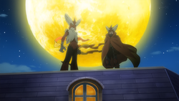

Mega Blaziken in the anime

In the main series
Several Mega Evolutions have been featured in the anime.
The first Mega Evolution in the anime was featured in Mewtwo — Prologue to Awakening, where Mewtwo was shown being capable of changing between its regular form and Mega Mewtwo Y form, in which its speed was dramatically boosted, being capable of moving faster than the blink of an eye. The same Mewtwo also played a major role in Genesect and the Legend Awakened, once again demonstrating its Mega Evolution capabilities. Unlike in the games, this Mewtwo seemed to be capable of Mega Evolving without the use of a Mega Stone.
Another Mega Evolution was featured in Kalos, Where Dreams and Adventures Begin!, where Ash saw a Mega Blaziken. In the next episode, it was revealed to belong to a masked hero called the Blaziken Mask, saving Ash from a free fall from the Prism Tower. The Mega Blaziken and its Trainer appeared again in Mega-Mega Meowth Madness!, helping Ash and his friends to destroy one of Team Rocket's mechas.
A couple of Mega Evolutions, including a Mega Ampharos, appeared as silhouettes in Kalos, Where Dreams and Adventures Begin! while Professor Sycamore told Ash, Clemont, and Bonnie about the concept of Mega Evolution.
In Mega Evolution Special I, a protagonist named Alain was featured traveling across the Kalos region with his Mega Charizard X, challenging other Mega Evolution Trainers. During the episode, Alain battled Astrid's Mega Absol and Remo's Mega Garchomp, and was victorious in both battles. Later in the special, he even faced the Elite Four member Siebold and his Mega Blastoise, but the powerful Water-type Pokémon proved to be too much for Charizard, causing Alain to lose the battle.
All known Mega Evolutions released at the time were also featured during the intro of the aforementioned special episode.
Diantha's Mega Gardevoir appeared in The Bonds of Evolution!, using its Mega Evolution powers to break free from Team Rocket's binds.
Korrina has a Lucario that can Mega Evolve, and so does her grandfather Gurkinn, as shown in The Aura Storm!. In Origins of Mega Evolution!, it was shown in a flashback how one of Gurkinn's ancestors discovered a Key Stone, while his Lucario discovered a Lucarionite, leading to the first known Mega Evolution.
A Trainer named Mabel and her Mega Mawile appeared in The Bonds of Mega Evolution!.
Diancie Mega Evolved in Diancie and the Cocoon of Destruction in order to protect the Allearth Forest from Yveltal and restore the Diamond Domain by creating a new Heart Diamond. At the end of the movie, it was shown that a diamond Diancie had created and given to Bonnie earlier caused it to Mega Evolve, acting as a Key Stone.
Steven Stone's Shiny Mega Metagross appeared in Mega Evolution Special II, as well as Mega Rayquaza. Both reappeared in SS032.
The intro of the aforementioned special episode also featured all newly revealed Mega Evolutions.
In SS032, Alain was seen battling a Trainer with a Mega Tyranitar in a flashback.
Professor Sycamore's Garchomp achieved Mega Evolution for the first time and Mega Evolved into a Mega Garchomp in Garchomp's Mega Bond!.

In Pokémon Origins
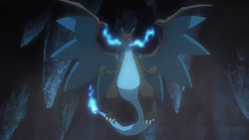

Mega Charizard X in Pokémon Origins
Red's Charizard was shown Mega Evolving into Mega Charizard X in the Pokémon Origins episode File 4 - Charizard during Red's battle against Mewtwo, thanks to the Charizardite X and Key Stone given to him by Mr. Fuji in an earlier episode.

In the manga
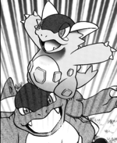

Mega Kangaskhan in the Pokémon Adventures manga
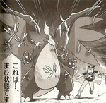

Mega Charizard X in The Legend of the Dragon King manga

In the Pokémon - The Legend of the Dragon King manga
In Pokémon - The Legend of the Dragon King, several main characters' Pokémon are capable of Mega Evolution, including Akira's Charizard, Koji's Garchomp, and Taichi's Ampharos.

In the Pokémon Adventures manga
Mega Evolution was first presented in the Pokémon Adventures manga in the X & Y chapter. When Team Flare members Aliana and Mable arrived in Vaniville Town in order to steal X's Mega Ring, the commotion caused X's baby Kangaskhan, Li'l Kanga, to react with X's Mega Ring and Mega Evolve into Mega Kangaskhan, easily defeating Aliana's Pyroar and Mable's Houndoom.
When X and his friends were attacked by Team Flare in Santalune City, Korrina arrived and Mega Evolved her Lucario into Mega Lucario to assist them.
While visiting Lumiose City, X met an Electrike, which led him to a Manectite, evolving into Manectric in the process. Later Manectric joins X's team, Mega Evolving into Mega Manectric while facing a Team Flare Grunt.
During a battle against Team Flare, Gurkinn's Gengar protected X from Celosia's Aegislash. It helped battle against Team Flare to stop them from capturing Xerneas while in tree form. It was later given it to X, at which point he nicknamed it Lasma. Lasna has a Gengarite, which allows X to Mega Evolve it into Mega Gengar.
In PAORAS01, Ruby, Sapphire, and Emerald were shown learning how to Mega Evolve their Pokémon from Ultima. Sapphire and Emerald are seen mastering it in PAORAS03, where they Mega Evolved their respective starter Pokémon.
In PAORAS02, Ruby was able to successfully Mega Evolve Latios into Mega Latios, allowing them to soar into the sky. He soon arrived at the Sky Pillar, where he met and battled Zinnia, who used her Mega Salamence against Mega Latios.

Trivia
- Every type has at least one Mega Evolution: Psychic has the most (with ten), while Ice and Electric have the fewest (with two each).
  - Electric is the only type for which no new Mega Evolution was introduced in Pokémon Omega Ruby and Alpha Sapphire.
- At least one Pokémon from every generation is capable of Mega Evolving: Generation III has the most (with twenty), while Generations V and VI have the fewest (with one each).
- Aerodactyl is the only Fossil Pokémon capable of Mega Evolving.
- With base stat totals of 780, Mega Mewtwo X, Mega Mewtwo Y, and Mega Rayquaza have the highest base stat totals of any Pokémon.
  - In addition, Mega Mewtwo Y has the highest base Special Attack of all Pokémon at 194, and Mega Mewtwo X has the highest base Attack of all Pokémon at 190. Mega Mewtwo X also has the highest base stat increase of all Mega Evolutions, its Attack stat being boosted by 80 upon the process.
- Aggron is the only dual-type Pokémon to become single-type upon Mega Evolving, going from Steel/Rock-type to pure Steel-type.
- Charizard and Mewtwo are the only two Pokémon with multiple Mega Evolutions. In both cases, the first ones to be revealed were the Y versions.
  - In addition, both of their Y versions kept their original type, while both of their X versions changed their type.
- Rayquaza is the only Pokémon that requires no Mega Stone to Mega Evolve, instead being required to know Dragon Ascent.
  - This makes Rayquaza the only Pokémon who can have a different held item while Mega Evolved, since Mega Stones cannot be taken off their proper holder during battle.
- Rayquaza is the only trio master capable of Mega Evolution.
- Diancie is the only Mythical Pokémon capable of Mega Evolution.
- Mega Latias and Mega Latios are programmed into Pokémon X and Y; as a result, they are not banned by the Kalos rules from battles, and they are not banned from trades between Omega Ruby or Alpha Saphire and X or Y, despite being unavailable in those games.

In other languages
Language |  | Title
Chinese | Cantonese | 超進化 Chīu Jeunfa
Chinese | Mandarin | 超進化 Chāo Jìnhuà
Finnish |  | Megakehitys
French |  | Méga-Évolution
German |  | Mega-Entwicklung
Hindi |  | Mega Evolution
Italian |  | Megaevoluzione
Korean |  | 메가진화 Mega Jinhwa
Polish |  | Megaewolucja
Portuguese |  | MegaEvolução
Brazilian Portuguese |  | Mega Evolução
Russian |  | Мега‐эволю́ция
Spanish |  | Megaevolución
Swedish |  | Mega-utveckling
Turkish |  | Mega Evrim
Vietnamese |  | Siêu Tiến Hóa

